Predicting predator search rates from metabolic rates; a bottom-up modelling approach.

Flavio Affinito1, Miguel Matias2, Samraat Pawar1 and Rebecca L. Kordas1

1. Department of Life Sciences, Imperial College London, Silwood Park Buckhurst Road, SL5 7PY, Ascot UK

2. Museo Nacional de Ciencias Naturales (CSIC), Madrid, 28006, Spain

Formatted for Functional Ecology

Title: currently 6629 words (including references) / 7500 max.

Abstract: currently 277 words / 350 max.

Figures: 1-7

Tables: 0

Equations: 9

Keywords: 9/8 max

References: currently 53[1]

Friendly reviewers (ideas): Tony Dell, Mary O’Connor

Official reviewers (ideas):

**Take home messages:**

1. The whole theoretical framework is sensible and should be adapted/repeated, as species metabolism adapts to temperature, their interactions change and adapt too
2. Predator taxa is benefitting disproportionately from warming of the environment (meta rates & mismatch)
3. Search rates in warm adapted spp seem to increase BUT it depends on spp/interaction type

**Abstract**

**1.** Species adaptation to changes in thermal regimes worldwide is observed in all temperature-dependent traits. Metabolic rates drive species biology and dynamics. We expect that as metabolic rates adapt to new environmental conditions these will result in new mismatches in performance of other biological traits, such as velocity, which will in turn affect predation dynamics via predator search rates.

**2.** Here, we develop a new theoretical framework relying on mathematical modelling of biological traits and empirical measurements of species’ metabolic thermal adaption. We test for thermal adaptation of three aquatic invertebrates and analyse how the ensuing adaptation patterns are reflected on predator search rates.

**3.** Our empirical work suggests that species adapt to warming by shifting their temperature performance curves vertically with temperature. We find that adaptation patterns are not consistent across species with temperature. Predator metabolic rates increase with warm adaptation whilst prey rates are highest for individuals adapted to intermediate temperatures.

**4.** Mechanistic modelling predictions reveal that the predator species in our system is benefitting disproportionately from the effects of warming via an increase in body velocity relative to that of its prey. This new performance mismatch is also recovered in search rate predictions where warm adapted predators display higher search rates than cold adapted ones regardless of prey type.

**5.** Ecologically sound modelling supported by robust empirical methods allows for the prediction of higher-level species dynamics from simple metabolic rates measurements. Our results provide the first attempt at providing a theoretical framework for predicting species interactions from temperature-dependence of metabolic rates. Key assumptions can be adapted to any system and will allow for a greater understanding of the effects of warming on biological systems.

**Keywords:** adaptation, temperature performance curve, respiration, search rate, velocity, metabolic rate, predator-prey, modelling, metabolic mismatch

**Introduction**

Temperature is one of the most important abiotic factors that influence ecological processes, from individual metabolism (Gillooly *et al.*, 2001) to ecosystem dynamics (Saxe *et al.*, 2001; Yvon-Durocher *et al.*, 2012). The past 50 years have revealed the fastest rise in temperatures ever recorded (Houghton, 1996; Stocker, 2014). These rapid increases in climatic temperature are already affecting a wide range of biological traits and ecological processes that depend on temperature (Coley, Bryant and Chapin III, 1985; Loreau *et al.*, 2001), having a direct impact on species and their interactions (Hughes, 2000; Peñuelas and Filella, 2001). Despite the extensive body of work on how temperature affects physiological rates (Gillooly *et al.*, 2001; Brown *et al.*, 2004), we still lack the necessary understanding to predict how future changes in global temperatures will affect species interactions. Recent work suggests that adaptation to differing thermal environments or regimes may cause “metabolic mismatches” between species with nontrivial consequences for predator-prey dynamics (Dell, Pawar and Savage, 2011).

Thermal performance curves (TPCs) of biological traits are key to understanding how temperature affects biological processes. TPCs display a unimodal relationship with temperature due to the temperature dependence of enzyme kinetics (Angilletta, 2006; DeLong *et al.*, 2017; Kontopoulos *et al.*, 2018; Fig 1A). Various scenarios of adaptation of TPCs to new thermal conditions are possible (Kingsolver, 2009; Fig 1B,C), which have higher-level effects on their population dynamics (Rall *et al.*, 2010; Vucic-Pestic *et al.*, 2011; Dell, Pawar and Savage, 2014; Gilbert *et al.*, 2014; Pawar, Dell and Savage, 2015). Of these adaptation scenarios, two key ones are displacement in temperature at peak performance (determined by *Tpk*, Fig 1C) and changes in the curve’s elevation (determined by the performance parameter *b0*, Fig 1B) (Angilletta, 2009). Both these have consequences for species interactions by producing mismatches in performance between predators and their prey (Dell, Pawar and Savage, 2014). Most species' biological rates do not match throughout their operational temperature range (OTR) (Fig 1D), indeed rates are typically higher for prey than for predators at the bottom of the temperature range (Dell, Pawar and Savage, 2011; Gilbert *et al.*, 2014; Ohlund *et al.*, 2014) As species adapt to new environments, new mismatches will arise and lead to new interactions (Fig 1E). These in turn will increase consumption rates, modify community dynamics and could lead to changes in ecosystem assemblage and increased extinction risk (Rall *et al.*, 2010; Albouy *et al.*, 2014).

In this study, we combine theory and data to study the drivers of adaptation in TPCs and quantify how changes in these biological parameters affect predator-prey dynamics via their effect on search rates. Temperature dependence of search rates has been suggested (Rall *et al.*, 2010, 2012; Vucic-Pestic *et al.*, 2011) but proper mechanistic understanding of the relationship is lacking.  Search rates are determined both by the biological traits of the resource and its consumer (Dell, Pawar and Savage, 2014; Gilbert *et al.*, 2014) and the environmental space they interact in (Pawar, Dell and Savage, 2012). Specifically, biotic effects on search rates are determined by the relative body velocities of the predator and its prey (McGill and Mittelbach, 2006; Pawar, Dell and Savage, 2012; Dell, Pawar and Savage, 2014). Research on animal locomotion suggests specific relationships between the energetic cost of transport and metabolic rate based on locomotion type (Tucker, 1970; Videler and Nolet, 1990; Videler, 1993; Alexander, 2003; Hein, Hou and Gillooly, 2012; Gilbert *et al.*, 2014). In part, the energy produced from respiration will be used up for muscle contraction and locomotion (Alexander, 2003). Thus, local adaptation of respiration TPCs will induce changes in velocity TPCs in turn affecting predator-prey ability to forage or escape. Hence, we consider how local adaptation of metabolic rates drives adaptation of species velocity and how the arising mismatches result in altered predator search rates.

Comprehensive mechanistic modelling of the effect of metabolism on species dynamics promises to yield invaluable insight into the temperature dependence of ecological processes (Dell, Pawar and Savage, 2014; Gibert and DeLong, 2014; Pawar, Dell and Savage, 2015). Here, we develop a theoretical framework to predict species interaction rates from individual-level metabolic (specifically respiration) rates from field data. Bridging the gap between metabolism, velocity and search rates via robust mathematical modelling allows for predictions of seldom measured search rates using commonly acquired respiration rates (Gillooly *et al.*, 2001; Brown *et al.*, 2004; Dell, Pawar and Savage, 2011; Huey and Kingsolver, 2011). We support our theoretical approach by integrating empirical work to understand the relationship between biological traits and species interactions with temperature. We use a space for time substitution for adaptation by sampling three taxa of aquatic invertebrates from a large mesocosm experiment set up in the Iberian Peninsula with sites located in regions varying in mean temperature. All three species of interest are widespread insects in Europe and fill different ecological niches: top predator, intermediate consumer and bottom-feeder. These taxa are locally adapted, which enables us to detect the effect of warming on their respective TPCs. We look for temperature-induced mismatches in the TPCs of velocity, to predict changes in species interactions for locally adapted populations.

To understand how adaptation to increases in global temperatures will affect species interactions, we investigate whether metabolic rate TPCs change between locally adapted populations, what parameters drive these changes and what effect these have on individuals species’ velocity and predator-prey search rates. Specifically, we ask (a) how are these taxa’s metabolic rates adapting to their thermal environment, (b) how does this metabolic adaptation affect mismatches in velocity and (c) how does this mismatch affect predator search rates? To address these questions, we analysed respiration TPCs of locally adapted populations to (i) test for expected adaptation scenarios in metabolic rates and (ii) analyse changes in biological parameters driving adaptation. We then investigate (iii) how adaptation of respiration TPCs cause mismatches in velocity TPCs of predator-prey pairs. Finally, we (iv) model the effects of local adaptation in velocity on predator search rates and (v) consider how adaptation to a warm environment changes search rate parameters.



Figure 1. **Thermal adaptation of temperature-dependent rates leads to new mismatches in performance between species.** Metabolic rates can be modelled as a unimodal function of temperature (A) determined by biochemical processes (enzyme activation (*Ea*) and deactivation (*Ed*) energies) and biological parameters (*Tpk* and *b0*) from equation 8. Adaptation to increases in temperature give rise to different patterns. Vertical shifts in performance (B) as *b0* changes with temperature or horizontal displacement in the whole TPC (C) as species adapt to a new *Tpk*, are expected to arise. This may lead to new mismatches in predator-prey traits, potentially affecting their dynamics at a given temperature (D-E). Adapted from Angilletta, 2009; Kingsolver, 2009; Anthony I Dell, Pawar and Savage, 2014.

**Modelling**

THE SEARCH RATE MODEL

We focus on “search rate’’, the rate at which a consumer “clears” or covers and area or volume while searching for prey. Previous work has shown that in field conditions, search rate is a key limiting rate underlying consumer-resource dynamics because it determines the rate of encounter when resources are relatively rare (McGill and Mittelbach, 2006; Pawar, Dell and Savage, 2012). Search rates are determined both by environmental space and biological traits as:

|  |  |  |
| --- | --- | --- |
|  | $$a= v_{r}D$$ | (1) |

Where *vr* is the relative velocity of a predator and its prey and *D* is the dimensionality component of search rates. Velocity is a biological rate that can be modelled as a function of temperature (Dell, Pawar and Savage, 2014). The temperature dependence of relative velocity for two species moving randomly can be included into equation 1 as:

|  |  |  |
| --- | --- | --- |
|  | $$a= \left(b_{0,c}{m_{c}}^{β_{c}}e^{\frac{{-E}_{c}}{k}\left(\frac{1}{T}-\frac{1}{T_{ref}}\right)}+\sqrt{1+{\left(\frac{b_{0,r}}{b_{0,c}}\right)}^{2}{\left(\frac{{m_{r}}^{β_{r}}}{{m_{c}}^{β_{c}}}\right)}^{2}e^{\frac{2}{k}\left(\frac{1}{T}-\frac{1}{T_{ref}}\right)\left(E_{c}-E_{r}\right)}}\right)D$$ | (2) |

Where *b0* is the normalisation constant for velocity at a reference temperature (*Tref*) set here at each site’s mean temperature, *m* is mass, *β* is the mass scaling exponent, *E* is activation energy, *T* is temperature, *k* is Boltzmann’s constant and *c* or *r* subscripts correspond to predator and prey parameters respectively. This model predicts the search rate of a predator foraging on an active moving prey in different environments, for benthic species, such as *Chironomus* spp., it can be adapted to a scenario for sessile prey by setting the prey’s velocity to 0:

|  |  |  |
| --- | --- | --- |
|  | $$a= b_{0,c}{m_{c}}^{β_{c}}e^{\frac{{-E}_{c}}{k}\left(\frac{1}{T}-\frac{1}{T_{ref}}\right)}D$$ | (3) |

We can expand the dimensionality term *D* for interactions taking place in 2D or 3D (Pawar, Dell and Savage, 2012). We modelled search rates separately in 2D or 3D interactions as follows:

|  |  |  |
| --- | --- | --- |
|  | $$2D :a=v_{r}2d_{0}{(m_{c}m_{r})}^{p_{d}}$$ | (4) |

|  |  |  |
| --- | --- | --- |
|  |  | (5) |

Where *d0* is the minimum reaction distance, *mc* and *mr* are average predator and prey body mass respectively, and *pd* is the scaling exponent of mass with dimensionality. The values of *pd* in 2D and 3D were empirically derived and are equal to 0.68 and 1.05 respectively (Pawar, Dell and Savage, 2012) .

The model’s output was compared between predator-prey pairs adapted to warm and mild environments to observe the effect of local adaptation on search rates. We used a linearised Arrhenius function to estimate the biological parameters determining search rates (*Ea* and *b0*) at each site and for each strategy and plotted the changes in parameter values to look for adaptation of search rates in warmer environments.

VELOCITY CALCULATIONS

All three taxa used in this study were aquatic invertebrates that were found swimming in the experimental ponds of our study area. The energetics of animal movement, and specifically swimming, have been extensively studied for various species (Videler and Nolet, 1990; Videler, 1993; Alexander, 2003). Assuming that velocity scales linearly with metabolic rate (Tucker, 1970; Alexander, 2003), there exists a relationship between cost of transport (*COT*), the amount of energy in J needed to transport 1N over 1min submerged swimmers, and metabolic rate (*B*). Rearranging Videler’s equation for velocity yields:

|  |  |  |
| --- | --- | --- |
|  | $$v= \frac{B}{COTmg}$$ | (6) |

Where *COT* is expressed in J.Nm-1, *B* is in J.s-1, *m* is mass in kg, *g* is gravitational acceleration in m.s-2 and *v* is velocity in m.s-1. *COT* was calculated from Videler’s relationship (Videler, 1993):

|  |  |  |
| --- | --- | --- |
|  | $$COT=1.1m^{-0.038}$$ | (7) |

We assumed that the energy provided for muscle contraction and velocity comes from the combustion of nutrients via oxygen consumption (Merrill and Watt, 1973; Elliott and Davison, 1975; Food and Agriculture Organization, 2015). Metabolism temperature performance curves of each predator-prey pair per site were thus converted into a measure of velocity using equations 6 and 7 and accounting for temperature dependence of *B:*

|  |  |  |
| --- | --- | --- |
|  | $$v=\frac{\left(\frac{b_{0}m^{β}e^{\frac{-E_{a}}{k}\left(\frac{1}{T}-\frac{1}{T_{ref}}\right)}}{1+ e^{\frac{E_{d}}{k}\left(\frac{1}{T_{pk}}-\frac{1}{T}\right)}}\right)γ}{1.1m^{0.962}g}$$ | (8) |

Where *γ* is the conversion coefficient of oxygen combustion into energetic output. There are known limitations to this model: measured metabolic rates are used as a function of velocity without taking into account increases in metabolism during activity and the efficiency of energy conversion by muscles is ignored. Nevertheless, this model is expected to provide us with a mechanistic prediction of species velocity which can in turn be used to predict predator search rates in various conditions and for any given species where mass and metabolic rates are known.

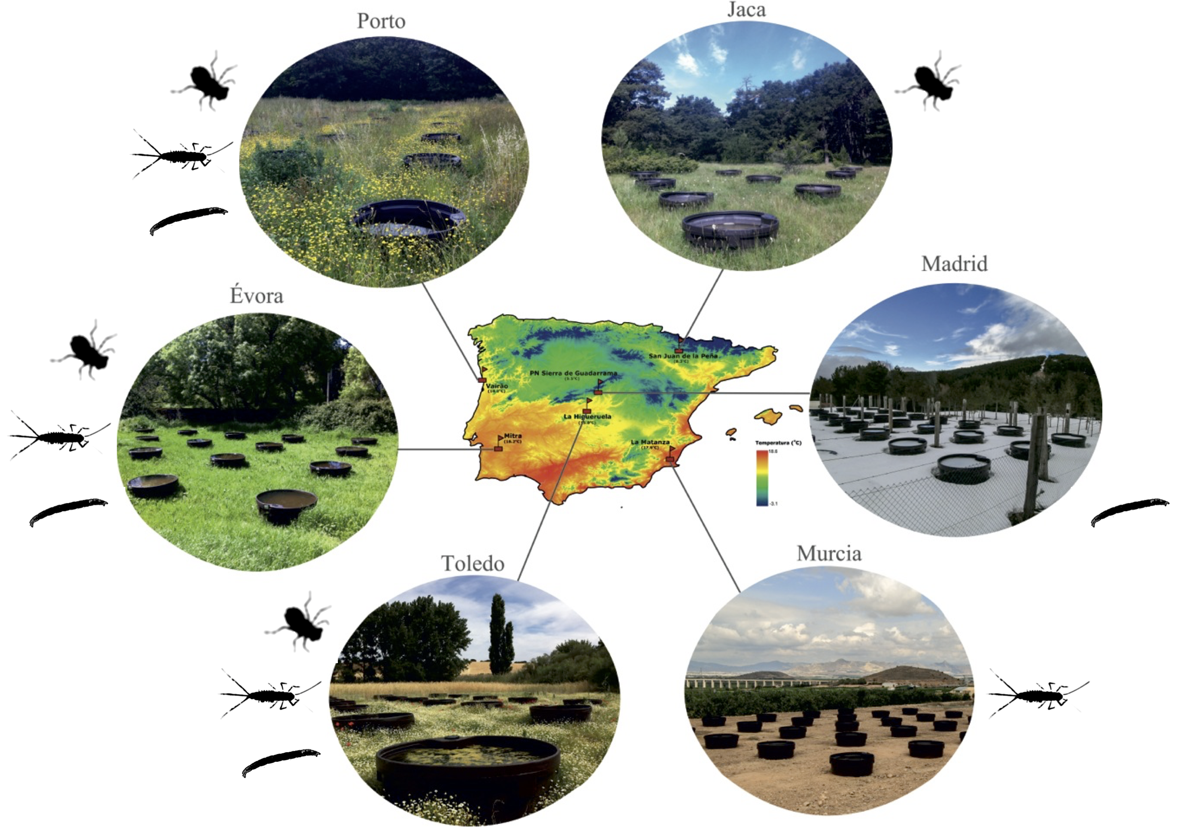

Figure 2. **The IberianPonds network is located in the thermally diverse Iberian peninsula.** The location of all six mesocosm experimental sites is shown with respect to a thermal map of the peninsula. Individual taxa sampled at each site are displayed (Jaca: *S. striolatum* alone; Madrid: *Chironomus* spp. alone; Murcia: *C. cloeon* alone). Taken from Matias (unpublished).

**Empirical Methods**

STUDY SITES

To determine how predator and prey species have adapted to different temperature conditions, we used a space for time substitution. We measured oxygen consumption rates of target species at six sites that varied in altitude and environmental conditions. These sites were spread throughout the Iberian Peninsula (Fig 2). At each site, 32 artificial mesocosm ponds (320L) were initially seeded in 2015 with an assemblage of locally sampled freshwater species. The communities in these ponds were then left to assemble naturally over the following two years. Most invertebrate species found in the ponds are efficient dispersers upon reaching adult stage and were found throughout ponds at each site (Matias, unpublished data). The sampling period for this study corresponded to the local spring season at each site (April to May, 2017). The sites experienced different local climates and average temperatures: Peñalara (7.35±0.05°C), Jaca (11.05±0.04°C), Porto (12.7±0.03°C), Toledo (13.47±0.03°C), Évora (14.92±0.03°C) and Murcia (16.23±0.03°C). Mesocosm temperatures were recorded with submerged loggers every hour since the set up of each experimental site.

STUDY ORGANISMS

Experiments were carried out on macro invertebrates native to ponds of the Iberian Peninsula. Individuals were collected with 500μm mesh nets from their home ponds and were identified to species level following experiments and preservation. We targeted species based on abundance at each site (>100 individuals) and trophic level (predator vs. prey). Not all species were found in sufficient numbers at all six sites (Fig 2).

Predator foraging strategy was determined for each prey based on differences in morphology and locomotive behaviour. In their larval stage, both *C. dipterum* and *S. striolatum* are free-swimming pelagic species (Merritt and Cummins, 1996; Bauernfeind and Soldan, 2012). In contrast, *Chironomus* spp. are benthic and found mostly hiding in the sediment (Cranston, Pinder and Armitage, 1995). We define foraging strategies based on the relative velocities of prey and predator (Pawar, Dell and Savage, 2012). When prey velocity is likely to be negligible relative to that of the predator, we classified it as a “sessile prey” strategy. In contrast, when prey velocity is non-negligible and likely to affect model predictions, we defined the foraging strategy as “active capture”. These distinct foraging strategies are expected to produce different interaction strengths based on the environmental space they occur in (equation 1) and are thus considered in conjunction for search rate modelling.

EXPERIMENTS

We measured oxygen consumption rate as a proxy for metabolic rate (Angilletta, 2009). Measures of metabolic rates were carried out using standard respiration protocol (Supplementary material, (Brodersen *et al.*, 2008)) with microelectrode oxygen sensors (Unisense, Denmark). We carried out respiration trials for all three taxa from each of the sites at 5°C intervals from 10°C to 45°C in order to characterize the entire TPC of respiration. Water temperature was controlled using a water bath. Two trials of 7 to 14 individuals each were carried out at each experimental temperature (Table S1). Prior to respiration, experiments sampled individuals were stored for 24h in pond water filtered with 53μmfollowed by 20μmmesh nets and held at ambient temperature. This allowed for gut clearing of all experimental individuals.

In order to calculate individual dry mass, a minimum of 50 individuals per taxa were collected from Murcia, Évora and Toledo. These were measured and dried in the oven at 80°C for 24hbefore being weighed. Length-weight regressions were estimated from these data (Supplementary material). Following experiments and preservation all other individuals were measured and dry weight was estimated from the regressions.

We proceeded to fit the Sharpe-Schoolfield model (Schoolfield, Sharpe and Magnuson, 1981) to the measured oxygen consumption rates. This model was chosen for its ability to capture both the rise and fall of temperature-dependent traits based on biologically relevant parameters. Not enough measurements were available to estimate low temperature enzyme inactivation thus the model used here reduces to:

|  |  |  |
| --- | --- | --- |
|  | $$B= \frac{b_{0}m^{β}e^{\frac{-E_{a}}{k}\left(\frac{1}{T}-\frac{1}{T_{ref}}\right)}}{1+ e^{\frac{E_{d}}{k}\left(\frac{1}{T_{pk}}-\frac{1}{T}\right)}}$$ | (9) |

Where *B* is oxygen consumption rate, *b0* is the normalisation constant at a reference temperature (*Tref*), *m* is mass, *β* is its scaling exponent, *Ea* is the enzyme’s activation energy, *Ed* is its deactivation energy, *k* is Boltzmann’s constant, *T* is temperature and *Tpk* is the temperature at which the *B* is maximised. Each site’s mean temperature was used as reference temperature (*Tref*) to estimate a biologically relevant value for *b0*. We fitted the model with a mass term added to account for species-specific variation in mass scaling for both prey species and set *β=0.75* (Brown *et al.*, 2004)for the predator taxa after a model choice procedure was carried out (Supplementary material). All parameters were estimated via non-linear least squares fitting of the model to the data collected for each species at each site using the ”minpack.lm” package (Elzhov *et al.*, 2016) for the statistical software R (R Core Team, 2015). Starting parameters for the fitting were sampled 10,000 times from a normal distribution centred on values estimated from a linearised Arrhenius function to determine the parameter values that yielded the best fit to the data. Best fit was determined based on highest R2 and lowest AIC and BIC when R2 values were equal.

Sharpe-Schoolfield models (equation 7) were fit to all the respiration data for each taxa at each site of occurrence. The best-fit model out of 10,000 runs in each case was kept to estimate the values of *Ea, Ed, B0, β* and *Tpk* (Table S4). Respiration curves were then plotted for each taxa at each site to compare adaptation patterns. Estimated parameter values were then compared between local populations at each site. Parameter values were considered statistically different from each other when associated confidence intervals did not overlap.

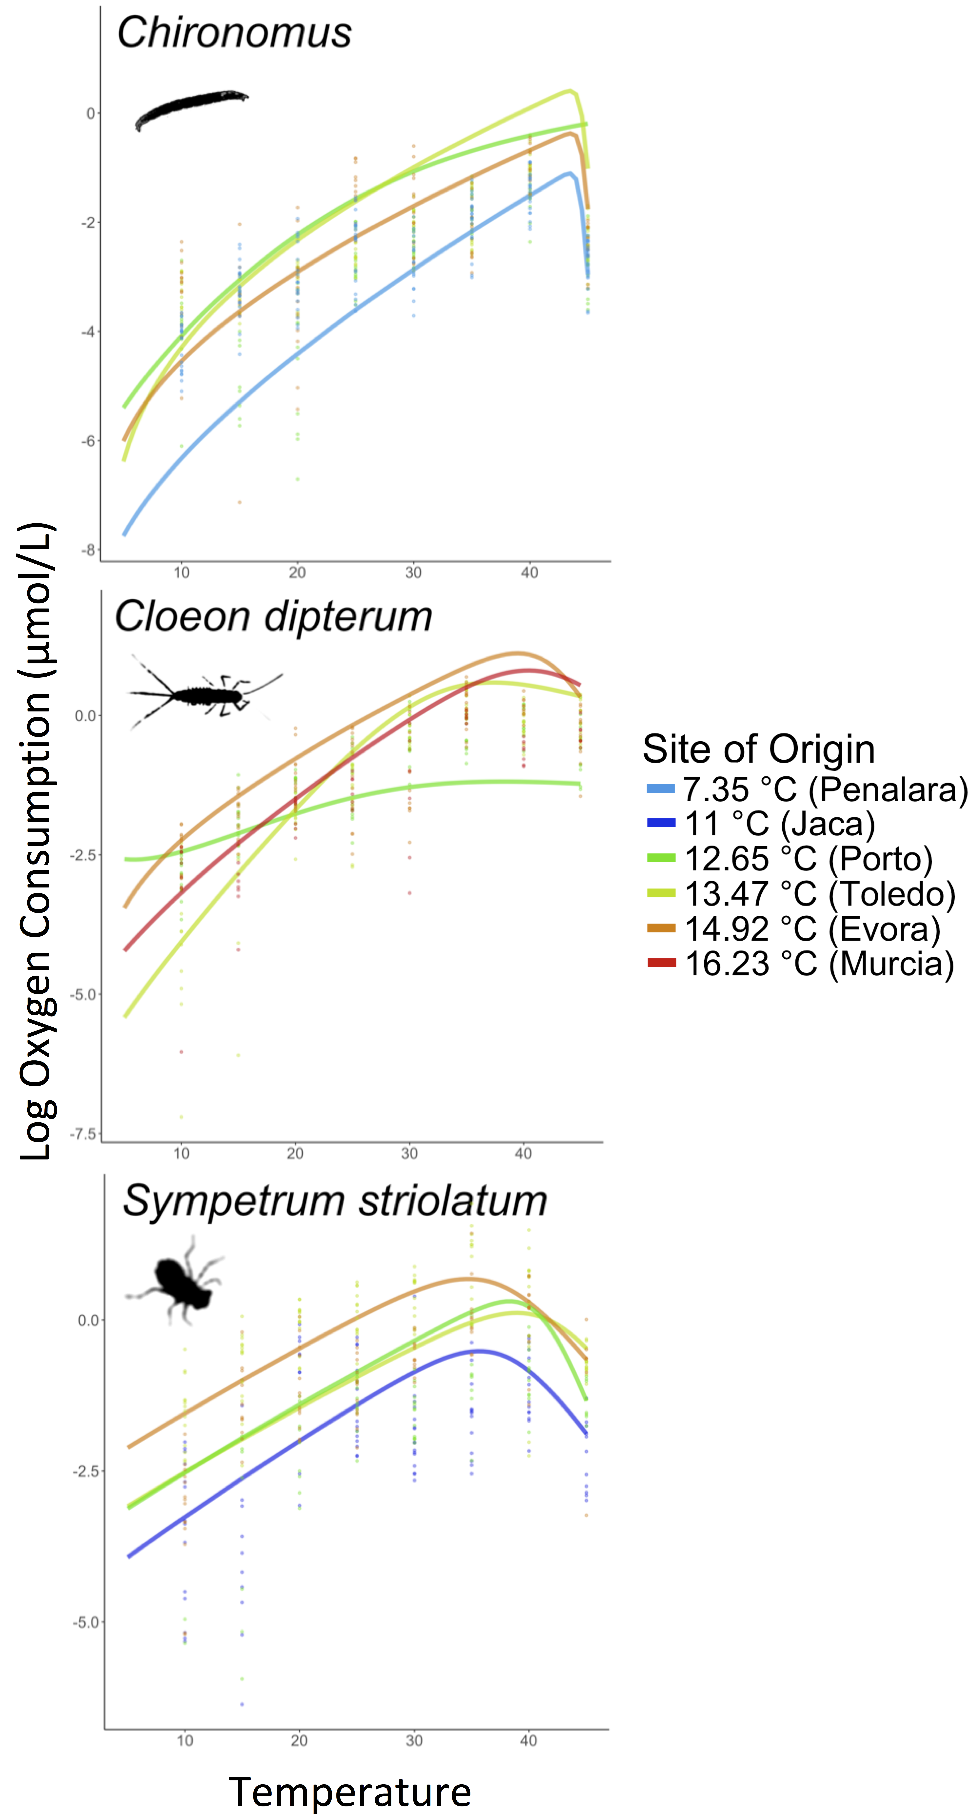

Figure 3. **Species specific metabolic rates TPCs vary with environmental temperature.** Respiration temperature performance curves for *Chironomus* *spp*, *C. dipterum* and *S. striolatum* display an adaptation scenario corresponding to conceptual Fig 1B. Note that curves for the coolest and hottest adapted populations are lower than those for intermediate sites for both prey species.

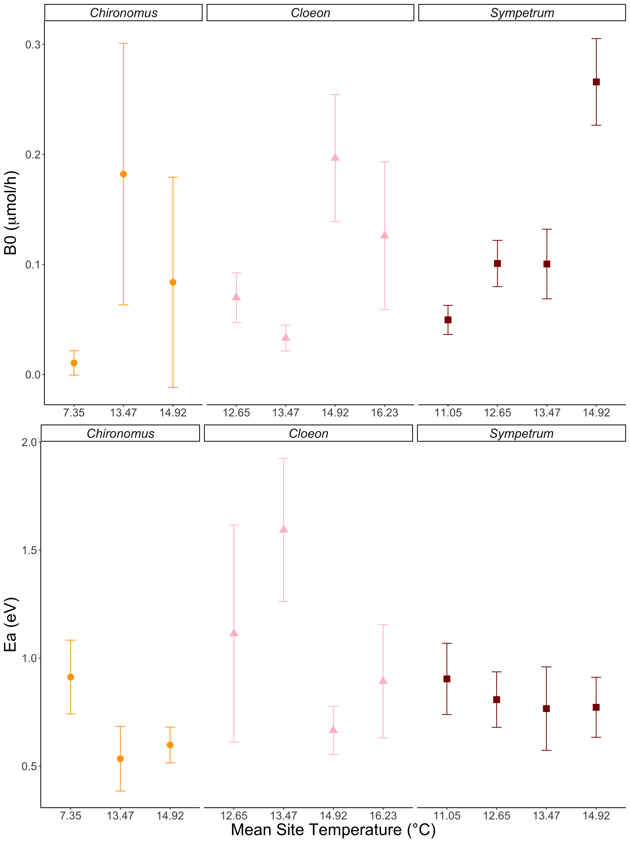

Figure 4. **Site dependent variation in model parameter estimates are strongest for elevation parameter *b0*.** Parameter estimates, associated to biological traits, show significant differences in adaptation to local thermal environments within taxa. Note that these significant differences are only *Tpk* when model convergence was poor (Porto).Values for *b0* and *Ea* vary with temperature for each taxa.

**Results**

The temperature dependence of respiration rate

Horizontal shift scenarios in TPC (Fig 1C) between locally adapted populations were not supported for any taxa (Fig 3). We failed to capture the falling part of the curve in Porto for both prey taxa resulting in model estimate of *Tpk* at the maximum valued allowed by the NLS fit: 80°C. At all other sites, temperature of peak performance for each taxa did not vary significantly as all *Tpk* confidence intervals overlapped (Fig 4). All three taxa adapted to new thermal environments by shifting their TPCs vertically (Fig 1B & 3). We recorded an increase in *b0* with site temperature for the predatory *S. striolatum*, *C. dipterum* displayed higher elevation for the warmer two sites in contrast to the cooler two and *Chironomus* spp. TPCs appeared to have higher *b0* at intermediate temperatures than at either extreme (Fig 3 & 4). Significant variation in *Ea* was recorded for both prey taxa in the cooler sites, with colder adapted populations showing steeper activation energies (Fig 4). No difference in activation energy between sites was found for *S. striolatum* (Fig 4).

As with respiration, no changes in velocity temperature performance curve *Tpk* were observed (43.5±3.4°C and 43.5±2.2°C for *Chironomus* spp., 37.4±2.9°C and 39.6±3°C for *C. dipterum*, 39±2.5°C and 34.7±1.9°C for *S. striolatum* in Toledo and Évora respectively). Curve elevation increased for all species: 0.07±0.028m.s-1 versus 0.09±0.023m.s-1 for *Chironomus* spp., 0.35±0.002m.s-1 versus 0.47±0.009m.s-1 for *C. dipterum* and 0.60±0.004m.s-1 versus 0.78±0.005m.s-1 for *S. striolatum* in Toledo and Évora respectively. We found higher elevation of the predator curve relative to the prey at warmer adaptation temperatures for both prey taxa: Δ*b0*=0.52m.s-1 versus Δ*b0*=0.69m.s-1 for *Chironomus* spp. and Δ*b0*=0.25m.s-1 versus Δ*b0*=0.32m.s-1 for *C. dipterum* in Toledo and Évora respectively. Adaptation to warmer environments increases elevation for all taxa but the relative difference in curve elevation increases as predator *b0* increases faster than that of either prey taxa (Fig 5).

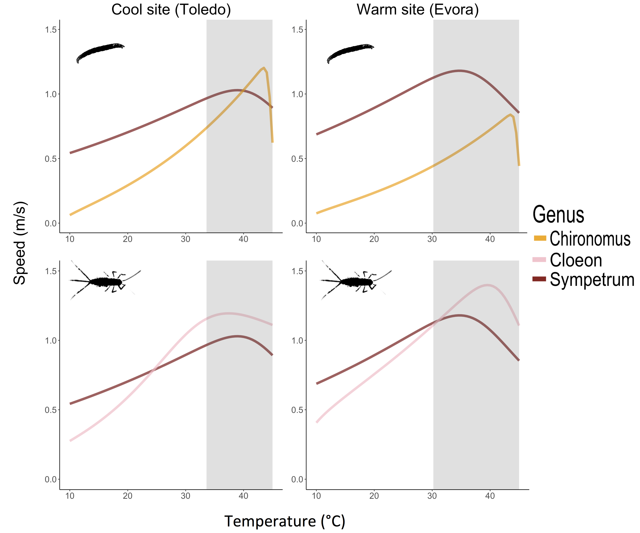

Figure 5. **Mismatches in velocity with adaptation temperature.** Predator-prey velocity curves for mild Toledo versus hot Évora for each predator-prey pair show mismatches in elevation and peak performance temperature. Changes in relative performance in warmer environments place both prey taxa under higher pressure from predation as *S. striolatum* displays relatively higher velocity over much of the operational temperature range.

EFFECT OF TEMPERATURE ON SEARCH AND ENCOUNTER RATES

Modelling search rates according to mechanistic parameters reveals that consistent patterns emerge in all scenarios. For both species pairs and all strategies at both sites, we find an exponential increase in search rates (Fig 6). The active 2D strategy displayed the highest search rates over the OTR in all cases. These were followed by 2D sessile prey model predictions for *Chironomus* spp. and 3D active prey predictions for *C. dipterum*. Search rates for the 3D sessile prey model were consistently smaller for both species pairs at each site. The remaining 3D strategy fell in between for *Chironomus* spp. whilst the last sessile strategy took that position for *C. dipterum*.

Activation energies of sessile search rate models increased by the same amount for both species pairs after warm adaptation (Fig 7). In contrast, *Ea* increased for active strategies for *Chironomus* spp. but decreased for *C. dipterum*. The elevation of search rate curves increased with adaptation to a warm environment irrespective of strategy for *Chironomus* spp. This increase was strongest for active strategies and for the 2D alternative in each foraging strategy. *C. dipterum* 3D and sessile 2D strategies increased in *b0* with warm adaptation. We found a small decrease in elevation for the *C. dipterum*’s active 2D model although large confidence intervals overlap with 0.

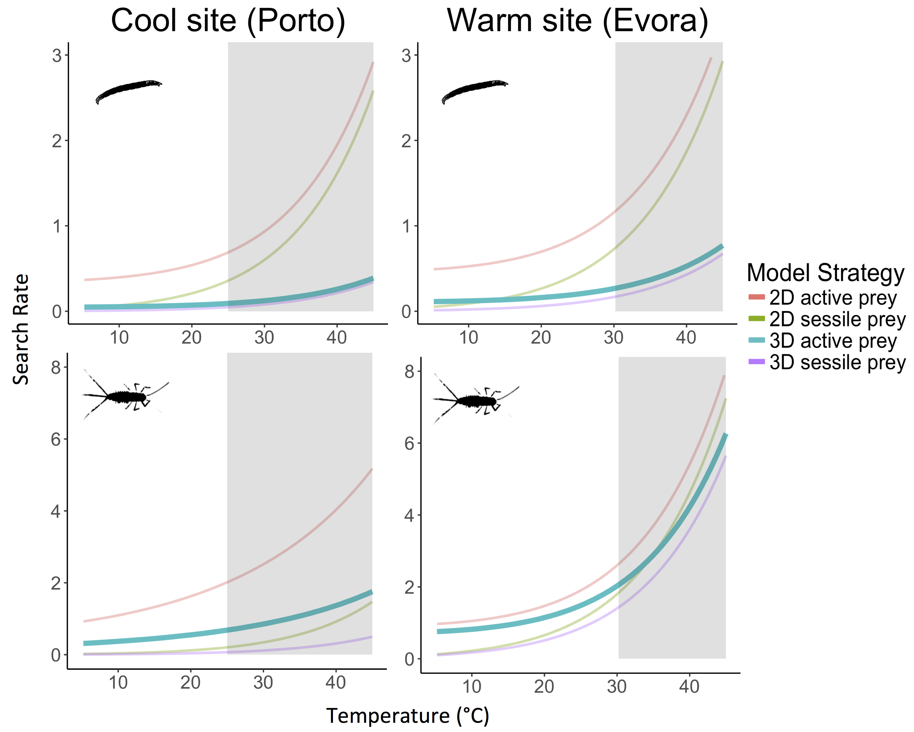

Figure 6. **Site-specific exponential increase in search rates with temperature.** Search rate models' predictions for spp. and *C. dipterum* in mild Porto or warm Évora show similar predictions in search rates within the OTR. Darker shaded curves correspond to the most biologically relevant model for the interacting pair. The model predicts exponential increases in search rate with temperature, but this increase is not equally strong for all strategies, and appears strongest in warm-adapted pairs.

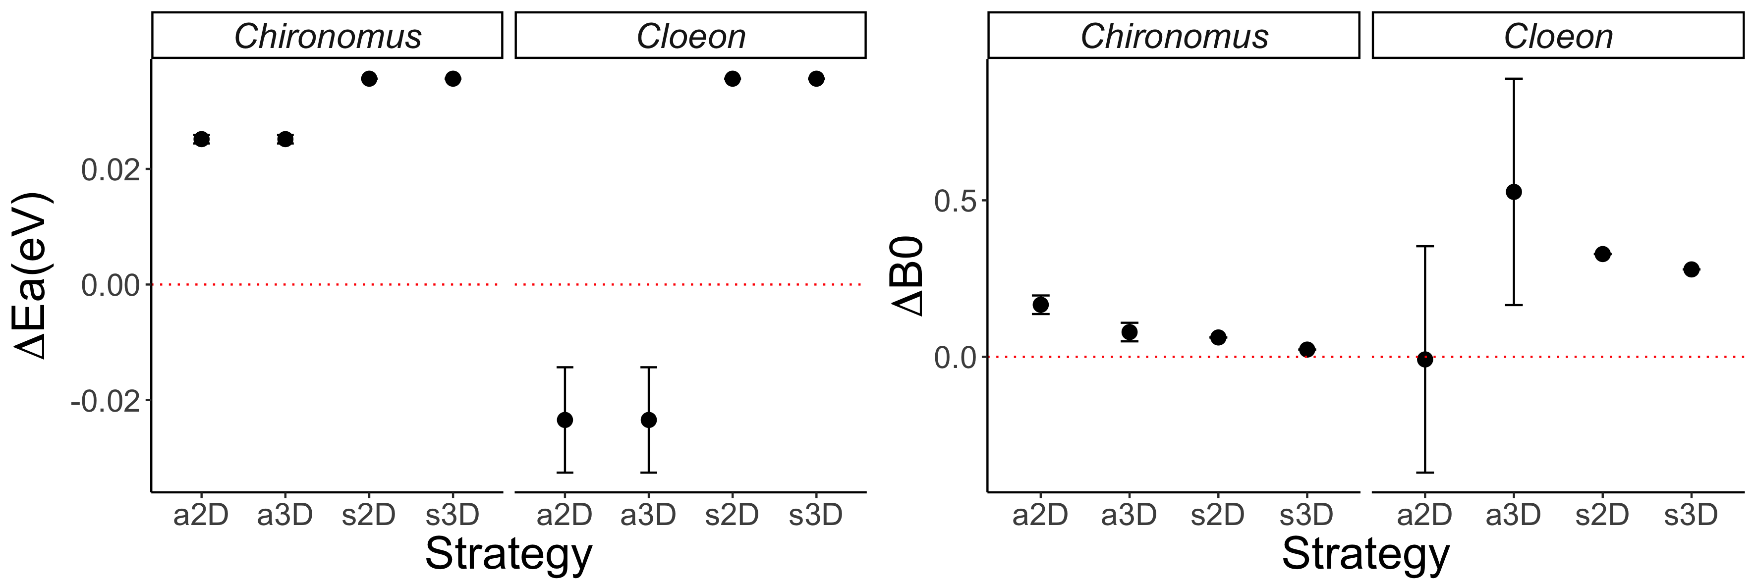

Figure 7. **Differences in search rate activation energy and baseline performance between warm and cold acclimated species.** Search rates for *Chironomus* spp.display an increase in both elevation (Δ*b0*) and activation energy (Δ*Ea*) for all strategies after adaptation to a warm site. Similarly, *C. cloeon* elevation increases for all strategies but active 2D, although large confidence intervals suggest a possible increase. In contrast, *C. cloeon* activation energy decreases for both active strategies in warm adapted taxa.

**Discussion**

Species-specific population temperature performance curves in this study display a vertical shift in the whole curve with increasing temperature (Fig 1B and 3). We did not observe any significant horizontal shift in the TPCs, typical of a shift in optimal performance temperature determined by trade-offs of performing better at higher temperatures and thus worse at lower ones (Fig 1C). The three taxa in this study have adapted their physiology by modifying their TPCs to better utilise the increase in available energy with temperature. Yet, this observed increase is not monotonous or consistent between species. Whilst the predatory dragonfly TPCs increase in elevation as they adapt to hotter sites such a relationship is not observed in their prey (Fig 3 and 4). Both prey species display lower elevation at temperature extremes than intermediate temperatures, suggesting a potential optimum adaptation towards the mid-range temperatures of the OTR. Furthermore, it is worth noting that the value for *Tpk* is higher than the operational range of temperature (Fig 3). Displaying *Tpk* values at unrealistically high temperatures of 35 °C or more provides a margin of safety to these taxa should climate change bring ambient temperatures higher than they currently are.

Converting metabolic rate measurements into velocity, a key driver of species interactions (Dell, Pawar and Savage, 2014), enabled us to directly consider the mismatch in functional trait performance between prey and predator in different species pairs (Fig 1D&E and 5). Our study suggests that species adapt to new environments within the limits imposed by their physiology and phenotypic plasticity, which will lead to differing changes in performance and thus interaction types and strengths (Angilletta, 2009; Kordas, Harley and O’Connor, 2011; Gibert and DeLong, 2014; Pawar, Dell and Savage, 2015). In this case, the predatory dragonflies of this species may be better able to feed on both these prey speciesthroughout their OTR as they are able to move faster, increasing potential attack and capture rates. Despite an increase in both prey velocity TPCs elevation, the increase in that of their predator causes a stronger mismatch in hotter environments. The monotonous increase in *S. striolatum* respiration *b0* measured here suggests this predator may be better suited at adapting to a warmer environment thus benefiting disproportionately from such environmental changes. Decreased oxygen concentration in warm water (Gilbert *et al.*, 2005) may be limiting both *C. dipterum*’s and *Chironomus* spp.’s ability to adapt to hotter environments. Indeed, mayfly and chironomid species are very sensitive to low *O2* environments (Panis, Goddeeris and Verheyen, 1996; Bauernfeind and Soldan, 2012). These results suggest that although species may adapt to an environment in similar ways, the magnitude of their scope for adaptation may cause new mismatches that will be detrimental to a species despite the apparent benefit of a warmer environment.

Predator-prey interactions are key to community-level dynamics in aquatic environments (Pawar, Dell and Savage, 2015). Here we show that it is possible to predict the behaviour of search rates from a mechanistic model relying on metabolic rates data. We find support for an exponential increase in search rates with temperature (Brown *et al.*, 2004; Vucic-Pestic *et al.*, 2011; Rall *et al.*, 2012). This relationship is maintained across foraging strategies but the magnitude of the increase varies, underlying the importance of environmental dimensionality in species interactions (Pawar, Dell and Savage, 2012). The strength of the relationship between search rates and temperature depends both on dimensionality and on the species operating in that space (Fig 6). Here, we find that dimensionality is playing a stronger role in search rates for *Chironomus* spp. whilst foraging strategy drives increased search rates in *C. dipterum*. Indeed, 2D environments display the sharpest increase for the former whilst it is active strategies for the latter. Thus, although biochemical processes result in similar patterns of search rate increase with warm adaptation, it is important to consider specific prey items and the environment they interact in when modelling search rates. Nonetheless, the overall increase in search rate elevation in warm adapted species (Fig 7) suggests that as the difference in performance of velocity increases, so do search rates. These results support the idea that the predator in this study will benefit disproportionately from the warming of its environment.

The set of assumptions of this model may limit its application to all types of predator-prey pairs. First, random movement has been shown to approximate animal dispersion in most cases but may not suffice in all (Pawar, Dell and Savage, 2015). Second, the effect of dimensionality is largely dependent on the environment and the predator’s detection mechanism, as *d0* (minimum detection distance) will depend both on the medium and trait used (Pawar, Dell and Savage, 2012). Third, the model uses an established relationship for general forms of movement in water and cost of transport (Tucker, 1970; Videler and Nolet, 1990; Videler, 1993). Alternatives can be used based on specific locomotion techniques and the physics involved therein but this was not available for our species (Alexander, 2003). We suggest that this drawback is only minor, for it is much easier to find information on higher taxa’s locomotion and work is on-going on the physics of animal movement with regard to metabolism (Hein, Hou and Gillooly, 2012; Gibert *et al.*, 2016). However, these shortcomings all point towards the fact that more empirical work on life history, habitat choice and animal movement is needed for a better integration of computational methods into biological studies. Finally, for ease of study and because no such information was available, we ignored energetic budgets and assumed that all the energy produced by metabolism was used for locomotion. This assumption will be broken in all cases as the energy produced by metabolism needs to be allocated to several other biological needs, such as growth and maintenance. Furthermore, of the energy allocated to locomotion, a large amount will be lost due to muscular inefficiency in most animals (Alexander, 2003). Indeed, up to 60% of the energy allocated for muscle contraction may be lost due to this inefficiency (Tucker, 1975; Alexander, 2005). Although these assumptions are most likely affecting our results, we suggest that this model can, and should, be easily adapted for taxa where more information is available and may lead to predictions that can be validated empirically. This in turn would be hugely beneficial in studies on the effects of global warming on the dynamics of predation as search rates are notoriously complicated to estimate experimentally (Rall *et al.*, 2010; Vucic-Pestic *et al.*, 2011).

The link between metabolic rates, velocity, their scope for adaptation and its effect on species interactions can be understood via mechanistic modelling. Species-specific metabolic adaptation to warmer environments (Fig 3), via changes in *b0* and *Ea* (Fig 4), transfers directly to mismatches in biological traits (Fig 5) and is recovered in search rate adaptation to temperature (Fig 6). The current increase in understanding of trait temperature-dependence and the mechanics of movement enabled the design of a biologically representative model based on empirical data gathered in the field. We reveal the patterns of thermal adaptation in a set of Iberian aquatic invertebrates and show how theoretical models enable qualitative predictions of complex biological traits and species interactions. Future work should focus on integrative approaches linking theoretical predictions to measured empirical data to understand the multi-level processes affecting thermal ecology. There is still much to understand about the effect temperature plays on metabolism and all the processes it controls. In the light of recent global warming, it is thus crucial that more effort be focused on the role temperature plays in all things related to life on Earth.

**Acknowledgements**

Special thanks go to Dr Katarzyna Sroczynska and Miss Càtia Lucio Pereira for their support in collecting the data used in this study.

**Authors contribution statement**

F. Affinito, M. Matias, S. Pawar and R. Kordas conceived the ideas and designed methodology;

F. Affinito, M. Matias and R. Kordas collected the data;

F. Affinito analysed the data;

F. Affinito led the writing of the manuscript.

M. Matias, S. Pawar and R. Kordas revised and corrected the manuscript.

All authors contributed critically to the drafts and gave final approval for publication.

**References**

Albouy, C. *et al.* (2014) ‘From projected species distribution to food-web structure under climate change’, *Global change biology*. Wiley Online Library, 20(3), pp. 730–741.

Alexander, R. M. (2003) *Principles of animal locomotion*. Princeton University Press.

Alexander, R. M. (2005) ‘Models and the scaling of energy costs for locomotion’, *Journal of Experimental Biology*, 208(9), pp. 1645–1652. doi: 10.1242/jeb.01484.

Angilletta, M. J. (2006) ‘Estimating and comparing thermal performance curves’, *Journal of Thermal Biology*, 31(7), pp. 541–545. doi: 10.1016/j.jtherbio.2006.06.002.

Angilletta, M. J. (2009) *Thermal adaptation: a theoretical and empirical synthesis*. Oxford University Press.

Bauernfeind, E. and Soldan, T. (2012) *The Mayflies of Europe (Ephemeroptera)*. Brill.

Brodersen, K. P. *et al.* (2008) ‘Respiration of midges (Diptera; Chironomidae) in British Columbian lakes: oxy-regulation, temperature and their role as palaeo-indicators’, *Freshwater Biology*. Wiley Online Library, 53(3), pp. 593–602.

Brown, J. H. *et al.* (2004) ‘Toward a metabolic theory of ecology’, *Ecology*. Wiley Online Library, 85(7), pp. 1771–1789.

Coley, P. D., Bryant, J. P. and Chapin III, F. S. (1985) ‘Resource availability and plant antiherbivore defense’, *Science*. American Association for the Advancement of Science, 230, pp. 895–900.

Cranston, P. S., Pinder, L. C. V and Armitage, P. D. (1995) *The Chironomidae : biology and ecology of non-biting midges / edited by P.D. Armitage, P.S. Cranston, L.C.V. Pinder*. Chapman & Hall London.

Dell, A. I., Pawar, S. and Savage, V. M. (2011) ‘Systematic variation in the temperature dependence of physiological and ecological traits’, *Proceedings of the National Academy of Sciences*, 108(26), pp. 10591–10596. doi: 10.1073/pnas.1015178108.

Dell, A. I., Pawar, S. and Savage, V. M. (2014) ‘Temperature dependence of trophic interactions are driven by asymmetry of species responses and foraging strategy’, *Journal of Animal Ecology*, 83(1), pp. 70–84. doi: 10.1111/1365-2656.12081.

DeLong, J. P. *et al.* (2017) ‘The combined effects of reactant kinetics and enzyme stability explain the temperature dependence of metabolic rates’, *Ecology and evolution*. Wiley Online Library.

Elliott, J. M. and Davison, W. (1975) ‘Energy equivalents of oxygen consumption in animal energetics’, *Oecologia*, 19(3), pp. 195–201. doi: 10.1007/BF00345305.

Elzhov, T. V *et al.* (2016) ‘minpack.lm: R Interface to the Levenberg-Marquardt Nonlinear Least-Squares Algorithm Found in MINPACK, Plus Support for Bounds’. Available at: https://cran.r-project.org/package=minpack.lm.

Food and Agriculture Organization (2015) *FAOSTAT*, *United Nations*.

Gibert, J. P. *et al.* (2016) ‘Crossing regimes of temperature dependence in animal movement’, *Global change biology*. Wiley Online Library, 22(5), pp. 1722–1736.

Gibert, J. P. and DeLong, J. P. (2014) ‘Temperature alters food web body-size structure’, *Biology letters*. The Royal Society, 10(8), p. 20140473.

Gilbert, B. *et al.* (2014) ‘A bioenergetic framework for the temperature dependence of trophic interactions’, *Ecology Letters*, 17(8), pp. 902–914. doi: 10.1111/ele.12307.

Gilbert, D. *et al.* (2005) ‘A seventy-two-year record of diminishing deep-water oxygen in the St. Lawrence estuary: The northwest Atlantic connection’, *Limnology and Oceanography*. Wiley Online Library, 50(5), pp. 1654–1666.

Gillooly, J. F. *et al.* (2001) ‘Effects of size and temperature on metabolic rate’, *Science*, 293(September), pp. 2248–2251. doi: 10.1126/science.1061967.

Hein, A. M., Hou, C. and Gillooly, J. F. (2012) ‘Energetic and biomechanical constraints on animal migration distance’, *Ecology Letters*, 15(2), pp. 104–110. doi: 10.1111/j.1461-0248.2011.01714.x.

Houghton, J. T. (1996) *Climate change 1995: The science of climate change: contribution of working group I to the second assessment report of the Intergovernmental Panel on Climate Change*. Cambridge University Press.

Huey, R. B. and Kingsolver, J. G. (2011) ‘Variation in universal temperature dependence of biological rates’, *Proceedings of the National Academy of Sciences*, 108(26), pp. 10377–10378. doi: 10.1073/pnas.1107430108.

Hughes, L. (2000) ‘Biological consequences of global warming: is the signal already apparent?’, *Trends in ecology & evolution*. Elsevier, 15(2), pp. 56–61.

Kingsolver, J. G. (2009) ‘The Well-Temperatured Biologist: (American Society of Naturalists Presidential Address)’, *The American Naturalist*. The University of Chicago Press, 174(6), pp. 755–768.

Kontopoulos, D.-G. *et al.* (2018) ‘Use and misuse of temperature normalisation in meta-analyses of thermal responses of biological traits’, *PeerJ*. doi: 10.7287/peerj.preprints.3068v1.

Kordas, R. L., Harley, C. D. G. and O’Connor, M. I. (2011) ‘Community ecology in a warming world: The influence of temperature on interspecific interactions in marine systems’, *Journal of Experimental Marine Biology and Ecology*, 400(1–2), pp. 218–226. doi: 10.1016/j.jembe.2011.02.029.

Loreau, M. *et al.* (2001) ‘Biodiversity and ecosystem functioning: current knowledge and future challenges’, *science*. American Association for the Advancement of Science, 294(5543), pp. 804–808.

McGill, B. J. and Mittelbach, G. G. (2006) ‘An allometric vision and motion model to predict prey encounter rates’, *Evolutionary Ecology Research*. Evolutionary Ecology, Ltd., 8(4), pp. 691–701.

Merrill, A. L. and Watt, B. K. (1973) ‘Energy value of foods: Basis and derivation’, *USDA. United States Department of Agriculture*. doi: 10.1017/CBO9781107415324.004.

Merritt, R. W. and Cummins, K. W. (1996) *An introduction to the aquatic insects of North America*. Kendall Hunt.

Ohlund, G. *et al.* (2014) ‘Temperature dependence of predation depends on the relative performance of predators and prey’, *Proceedings of the Royal Society B: Biological Sciences*. doi: 10.1098/rspb.2014.2254.

Panis, L. I., Goddeeris, B. and Verheyen, R. (1996) ‘On the relationship between vertical microdistribution and adaptations to oxygen stress in littoral Chironomidae (Diptera)’, *Hydrobiologia*. Springer, 318(1–3), pp. 61–67.

Pawar, S., Dell, A. I. and Savage, V. M. (2012) ‘Dimensionality of consumer search space drives trophic interaction strengths’, *Nature*. Nature Publishing Group, 486(7404), pp. 485–489. doi: 10.1038/nature11131.

Pawar, S., Dell, A. I. and Savage, V. M. (2015) ‘From metabolic constraints on individuals to the dynamics of ecosystems’, *Aquatic functional biodiversity: an ecological and evolutionary perspective*, pp. 3–36.

Peñuelas, J. and Filella, I. (2001) ‘Responses to a warming world’, *Science*. American Association for the Advancement of Science, 294(5543), pp. 793–795.

R Core Team (2015) ‘R: A Language and Environment for Statistical Computing’. Vienna, Austria. Available at: https://www.r-project.org/.

Rall, B. C. *et al.* (2010) ‘Temperature, predator--prey interaction strength and population stability’, *Global Change Biology*. Wiley Online Library, 16(8), pp. 2145–2157.

Rall, B. C. *et al.* (2012) ‘Universal temperature and body-mass scaling of feeding rates’, *Phil. Trans. R. Soc. B*. The Royal Society, 367(1605), pp. 2923–2934.

Saxe, H. *et al.* (2001) ‘Tree and forest functioning in response to global warming’, *New Phytologist*. Wiley Online Library, 149(3), pp. 369–399.

Schoolfield, R. M., Sharpe, P. J. H. and Magnuson, C. E. (1981) ‘Non-linear regression of biological temperature-dependent rate models based on absolute reaction-rate theory’, *Journal of theoretical biology*. Elsevier, 88(4), pp. 719–731.

Stocker, T. (2014) *Climate change 2013: the physical science basis: Working Group I contribution to the Fifth assessment report of the Intergovernmental Panel on Climate Change*. Cambridge University Press.

Tucker, V. A. (1970) ‘Energetic cost of locomotion in animals’, *Comparative Biochemistry and Physiology*. Elsevier, 34(4), pp. 841–846.

Tucker, V. A. (1975) ‘The energetic cost of moving about: walking and running are extremely inefficient forms of locomotion. Much greater efficiency is achieved by birds, fish—and bicyclists’, *American Scientist*. JSTOR, 63(4), pp. 413–419.

Videler, J. J. (1993) *Fish swimming*. Springer Science & Business Media.

Videler, J. J. and Nolet, B. A. (1990) ‘Costs of swimming measured at optimum speed: scale effects, differences between swimming styles, taxonomic groups and submerged and surface swimming’, *Comparative Biochemistry and Physiology Part A: Physiology*. Elsevier, 97(2), pp. 91–99.

Vucic-Pestic, O. *et al.* (2011) ‘Warming up the system: higher predator feeding rates but lower energetic efficiencies’, *Global Change Biology*. Wiley Online Library, 17(3), pp. 1301–1310.

Yvon-Durocher, G. *et al.* (2012) ‘Reconciling the temperature dependence of respiration across timescales and ecosystem types’, *Nature*. Nature Publishing Group, 487(7408), p. 472.

1. Correspondence : flavio.affinito@gmail.com